**Design of hydrophone for UPPER**

**Part List:**

1. 1 Plastic box with approximately 4.5 inch diameter and 6 inch height as shown in figure

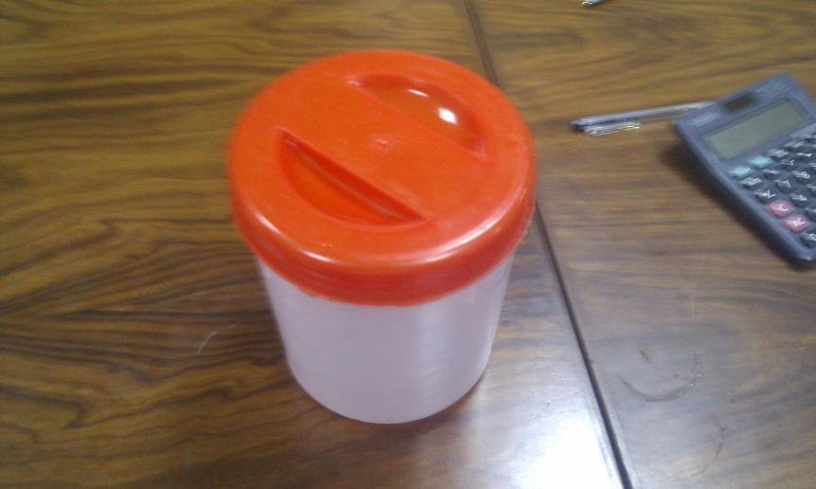

1. One 17 KHz Piezoelectric cylinder with soldered terminals as shown in figure. (By STEMinc, Manufacturer part number: SMC5447T40111)

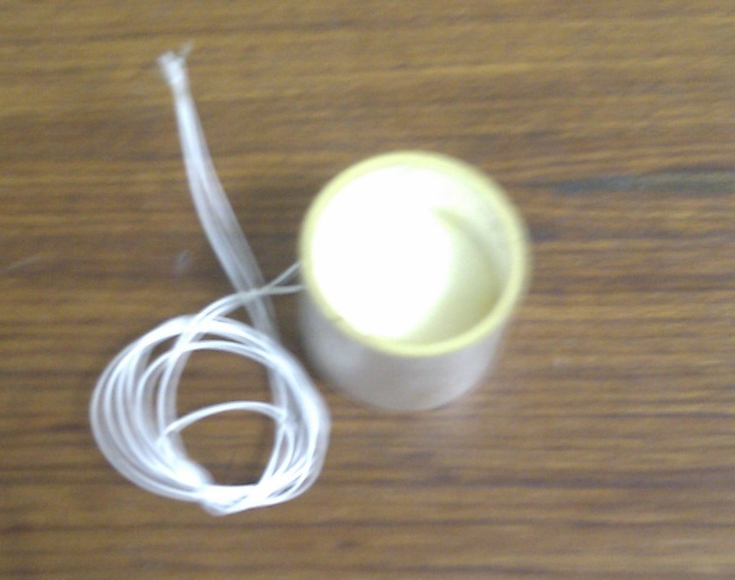

1. Vegetable oil: 2 liter.
2. Foam, as shown in figure.

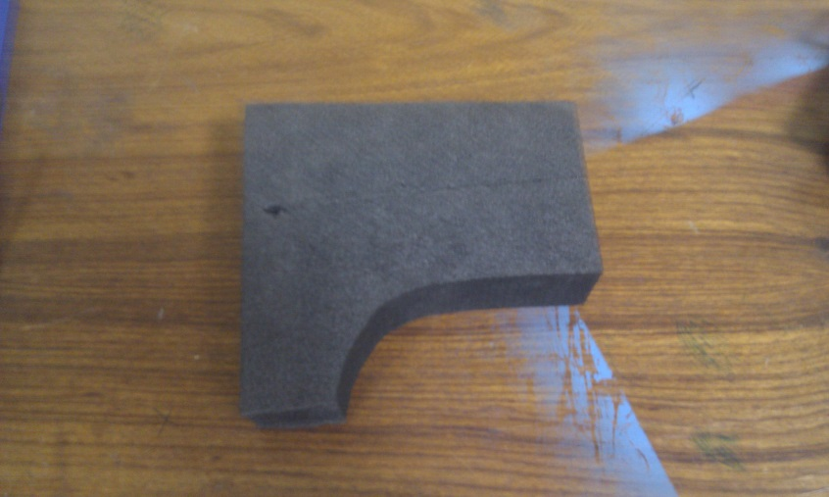

1. 2 Inner and outer threaded rods of 0.5 inch diameter with hollow center as shown in figure ?.

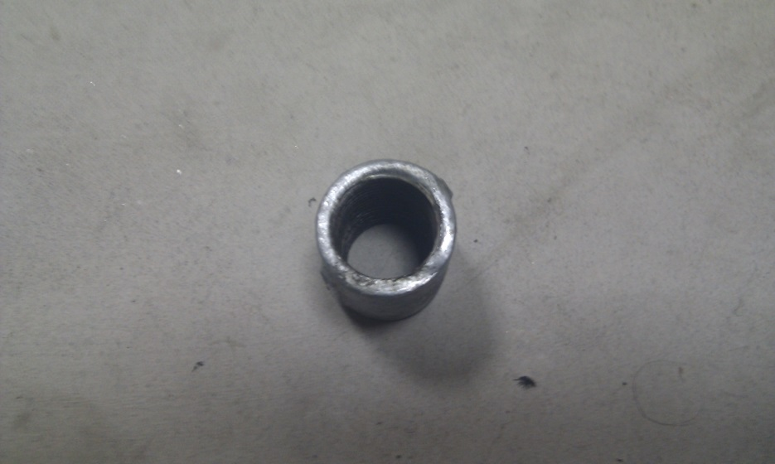

1. 1 outer top and bottom outer threaded rod of 0.5 inch diameter with hollow center as shown in figure.

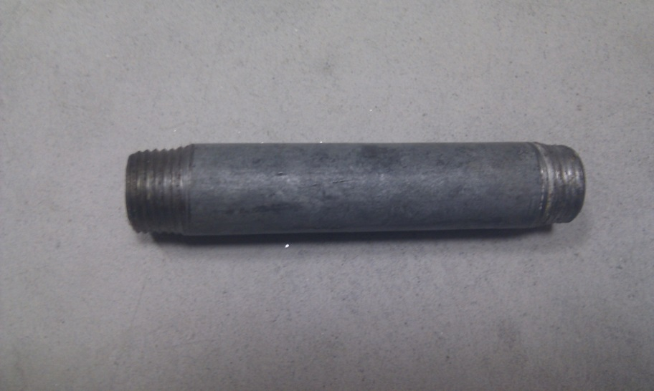

1. 1 worm clamp, which can easily be fitted on 0.5 inch diameter, as shown in figure.

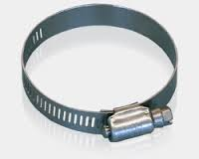

1. Flexible plastic pipe of 0.5 inch diameter and length of 6 meter, as shown in figure.

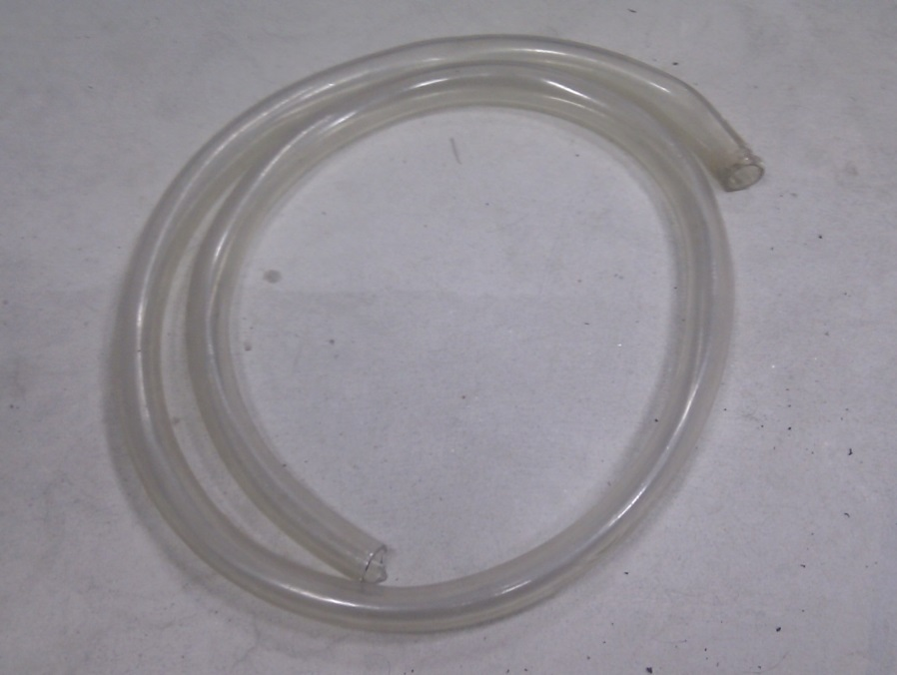

1. Shielded audio cable of length 10 meter, as shown in figure.

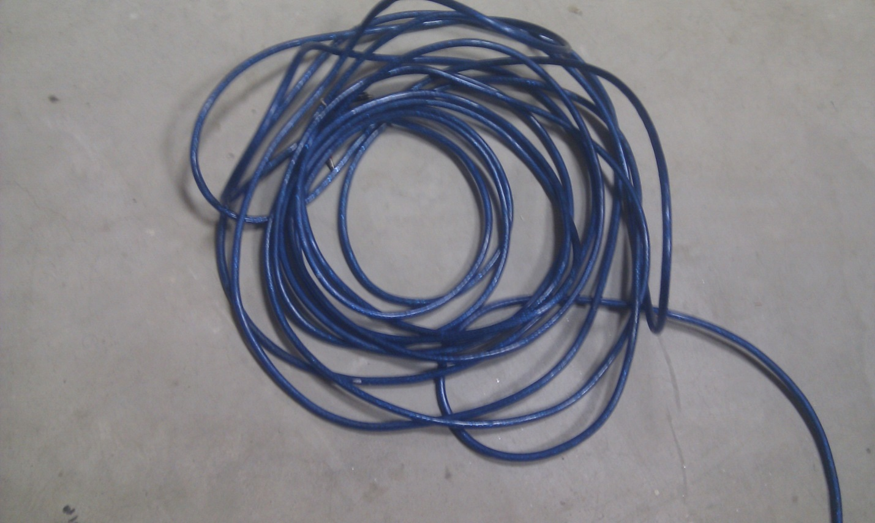

1. 2 Teflon tapes.
2. 1 Silicon sealant. 100gm
3. 2 crocodile clips.

**Steps for design a Low cost hydrophone for UPPER:**

1. Take two wires of gauge 24 and length 12 inch each. Solder one wire at the inner side of the piezoelectric cylinder and the second wire on its outer side as shown in the figure.

(**Note: Follow the soldering instructions available on the link** [**http://www.steminc.com/piezo/PZ_property.asp**](http://www.steminc.com/piezo/PZ_property.asp)**)**

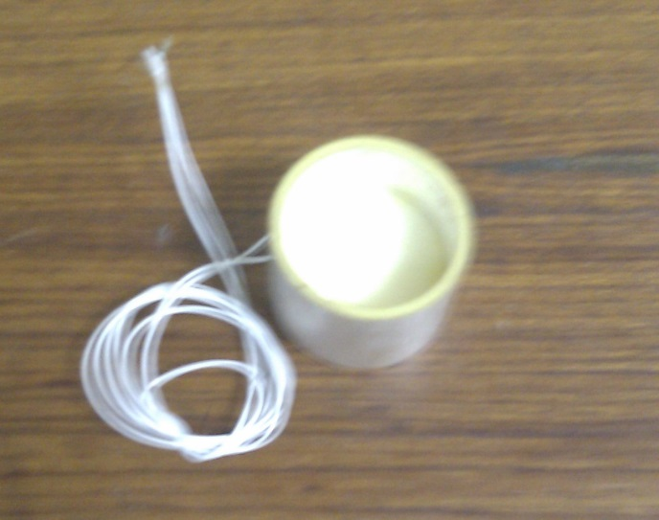

1. Take foam, and cut it in a T shape. Make sure that leg of the T is cut round with the diameter a little more than the inner diameter of the piezoelectric cylinder. And top of line of T should have the dimensions as shown in the figure.

(**Note: The dimensions of the top line of T are in accordance with the box we are using, it can be changed according to the dimension of the box in use.)**

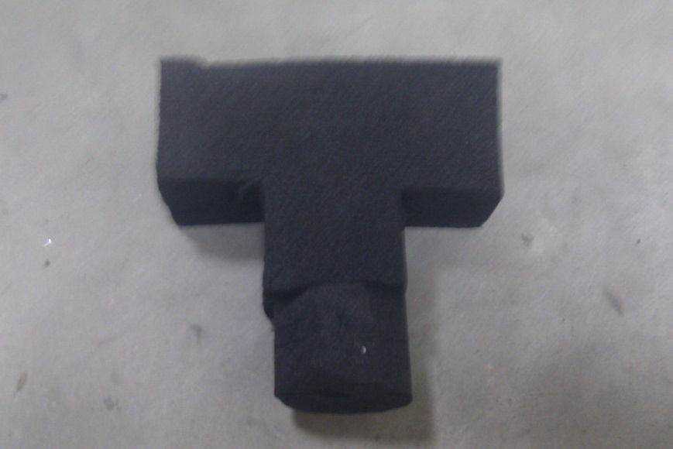

1. Make a hole at the top center of T shaped foam of diameter approximately 0.45 inch (should be less than 0.5 inch) and of length 5inch and then extend it to the leg of T with the diameter of 0.1 inch as shown in figure.

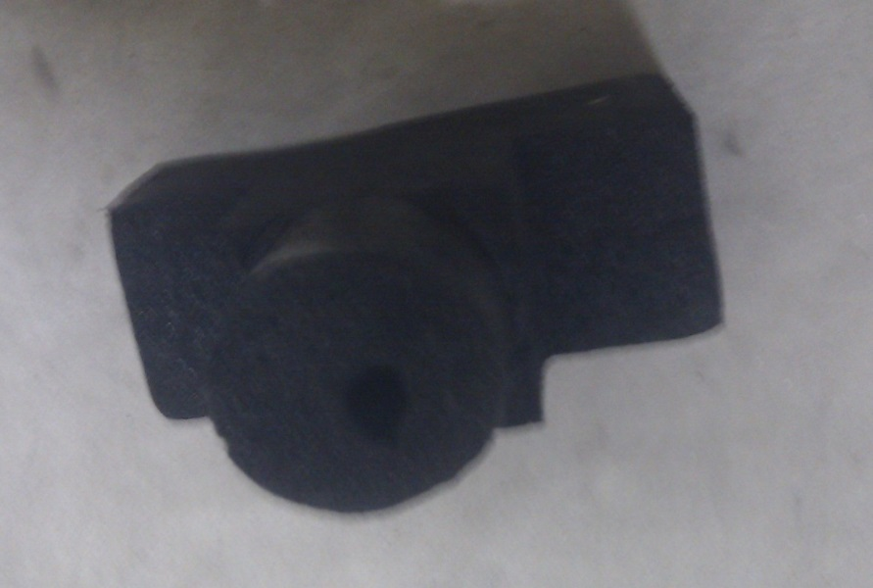

1. Now fix the piezoelectric cylinder on the leg of the T as shown in the figure.

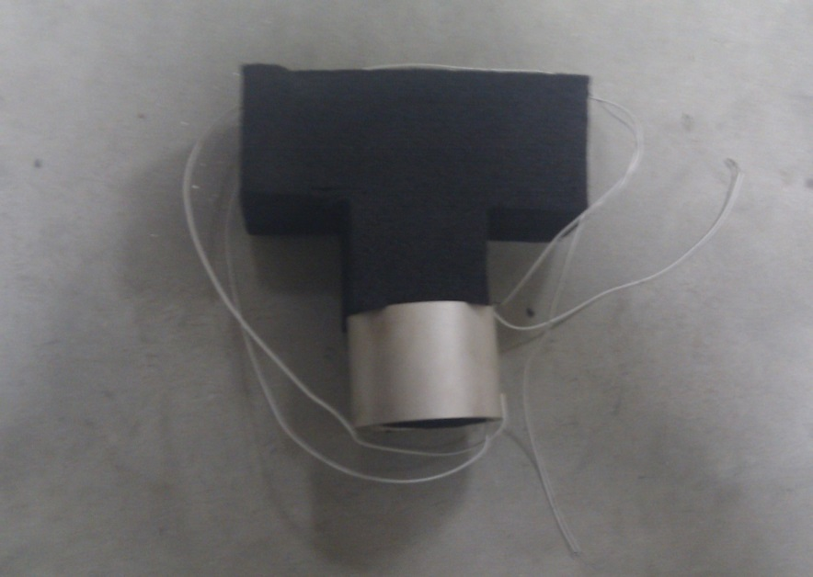

1. 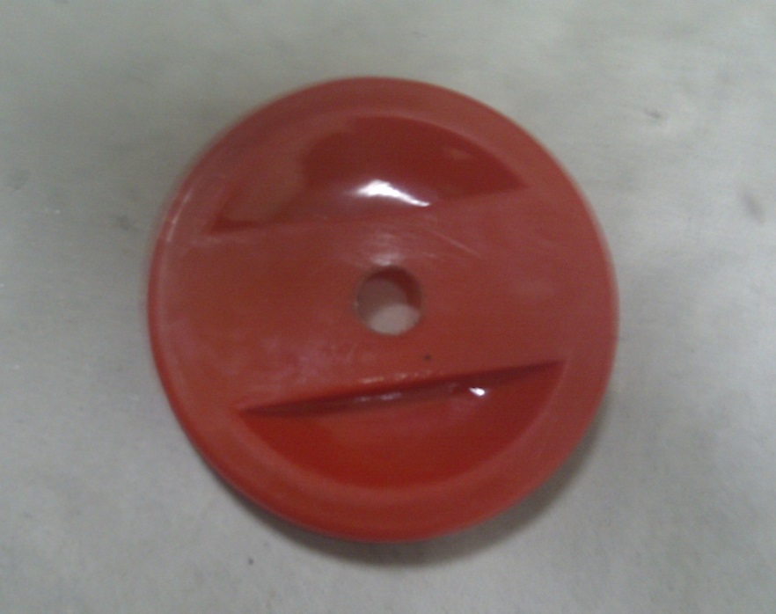Make a hole of approximately 0.5 inch diameter at the center of the cover of the box shown in figure.
2. Pass the outer threaded part of one of the inner and outer threaded rod of 0.5 inch through this hole from the top side of the box cover as shown in figure.

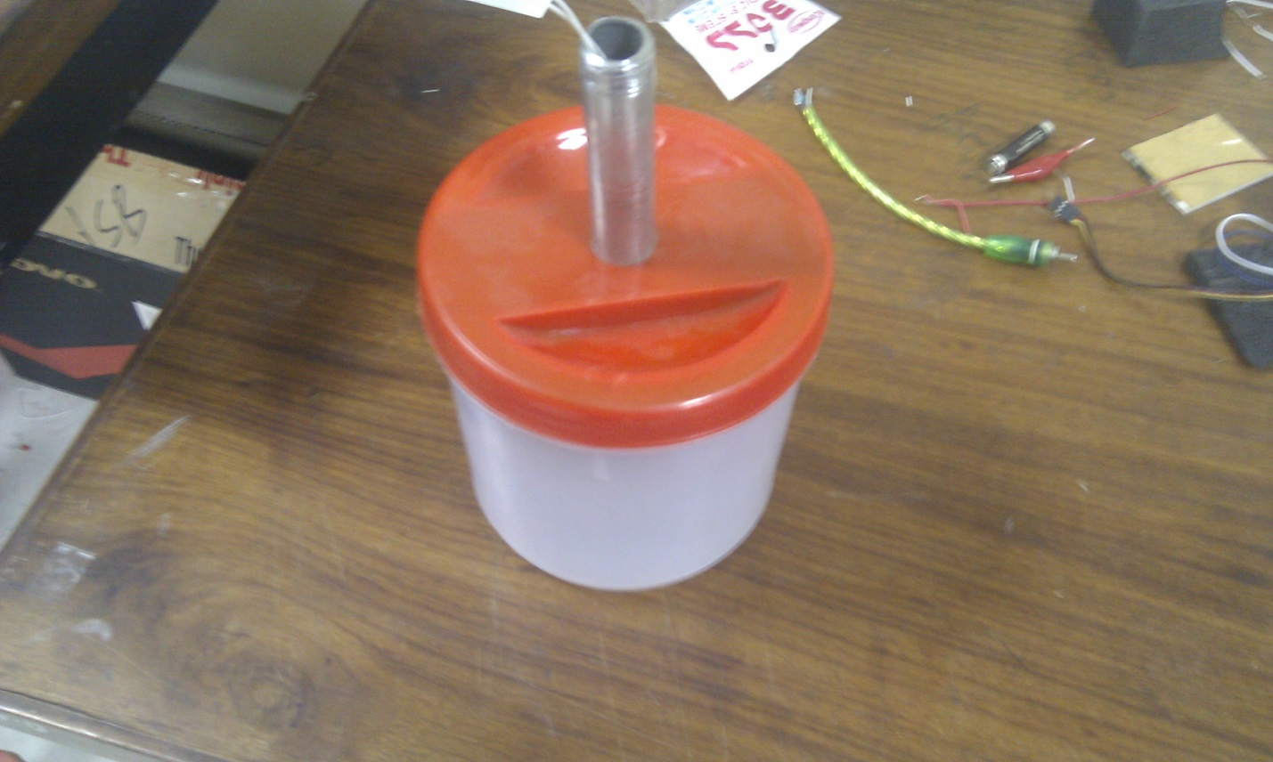

1. Connect the other inner and outer threaded rod to the already connected (or passed) rod at the bottom side of the box’s cover as shown in figure.
2. Connect the outer top and bottom threaded rod of 0.5 inch diameter to the inner and outer threaded rod. Use Teflon tape on the threads for sealing.
3. Fix the T shaped foam at the bottom of the box’s cover as shown in figure.

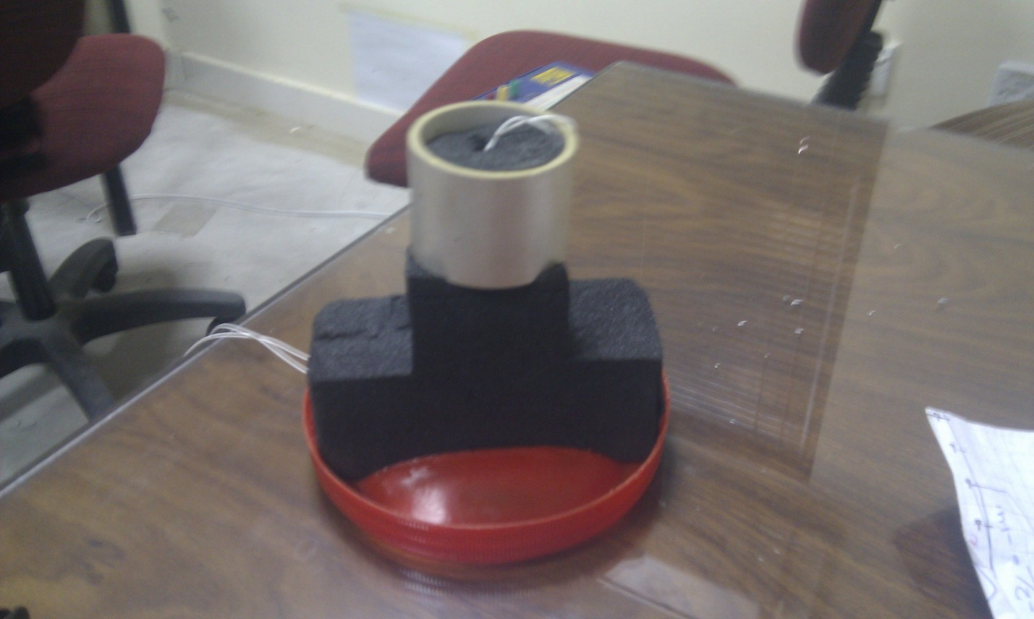

1. Pass the wires connected to the piezoelectric cylinder the hole of T shape foam and from rods, so that wires show up at the top.
2. Solder the shielded audio cable with the wires showed at top (in last step).
3. Fill the box with vegetable oil. (Note: Do not fill it completely as structure attached to box’s cover has to be submerged in the oil, which will raise the height of the oil.)
4. Fix the box cover on top of the box.
5. Make sure to seal the box properly using silicon sealant and cover it with the Teflon tape as mentioned point in the figure. It is required that the box is properly sealed so that either water or oil can go in and of the box. (Note: You can use any preferred sealant other than silicon which can prevent water of being inside the box)
6. If there is a need to add more oil in the box, it is possible to add from the opening available at top of outer top and bottom threaded rod as mention. If there is no need to add more oil than the rod’s top can be closed by using small piece foam.
7. Pass the shielded audio cable through the plastic pipe shown in the figure.

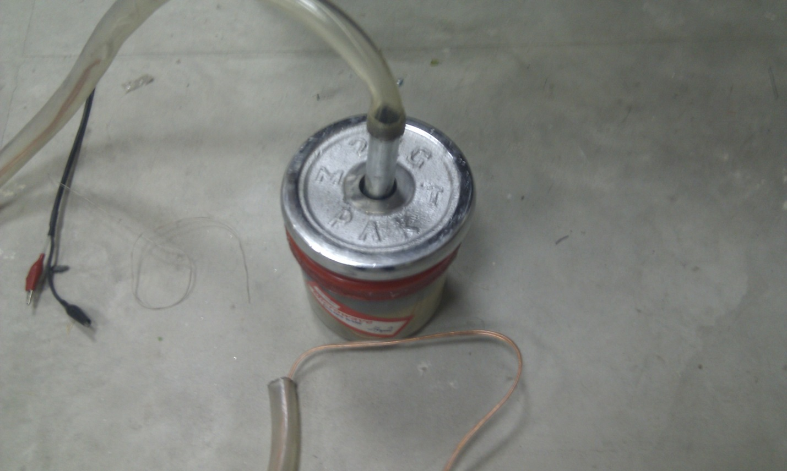

1. Fix the pipe on top of the outer top and bottom threaded rod and fix it by using worm clamp as shown in figure.

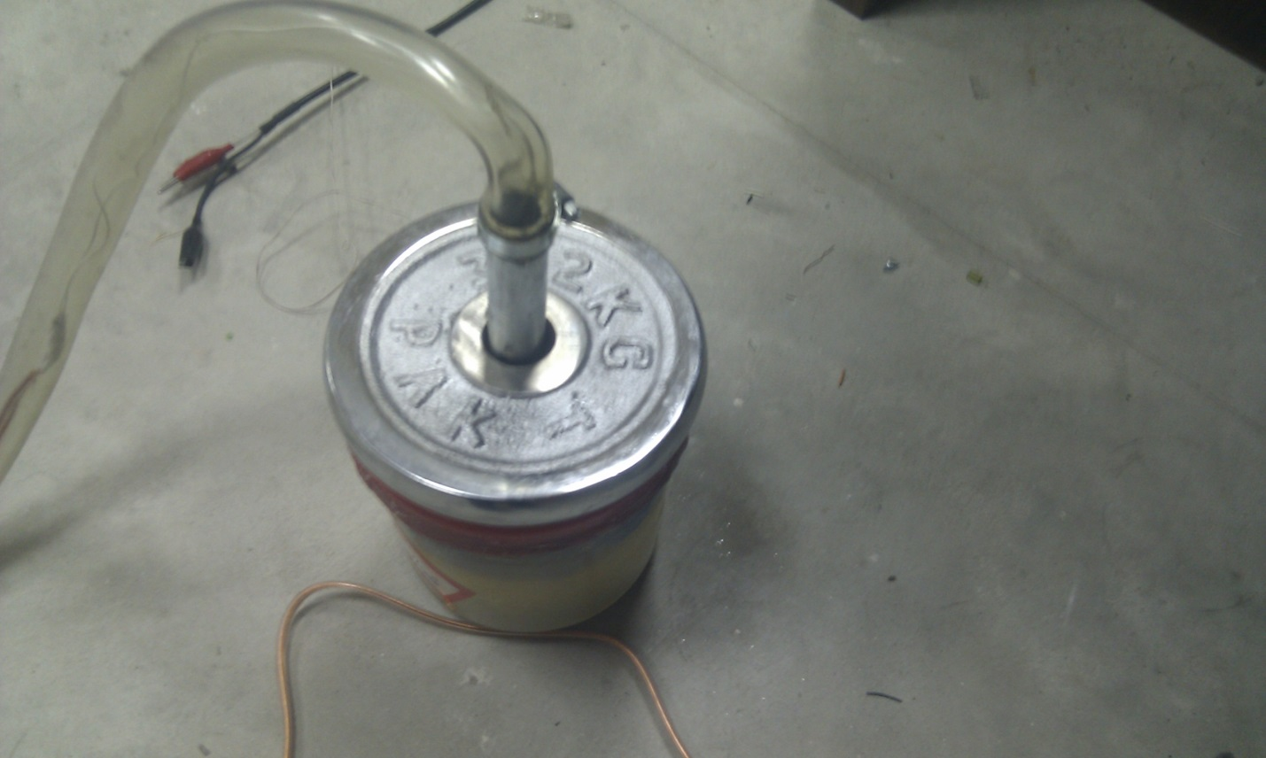

1. Attach crocodile clips to the wires of audio cable as shown in figure.

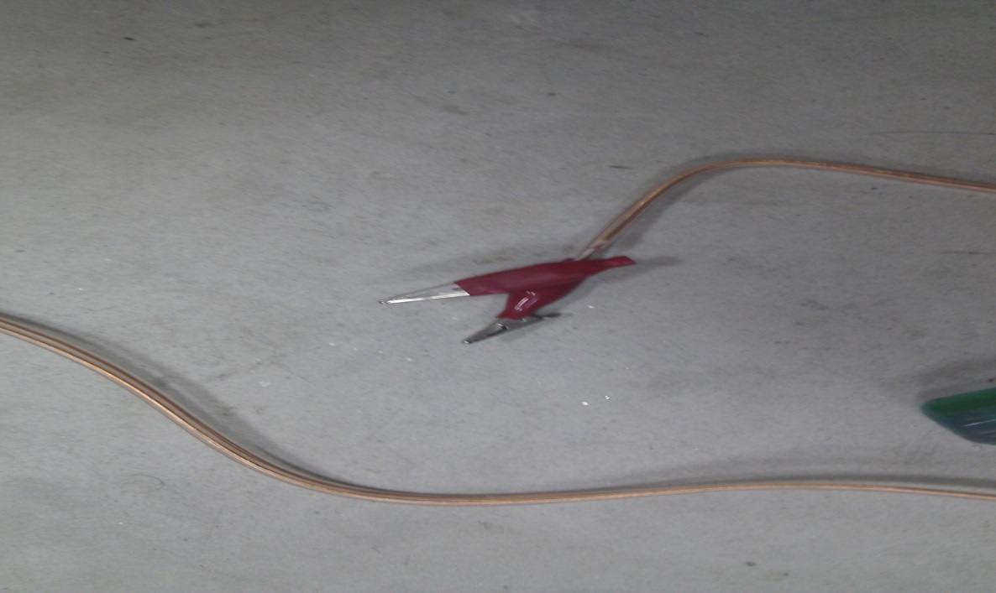

This concludes the design of the underwater acoustic hydrophone.

